Name _______________________________________________
Rubric for Comic Strip Tutorial

Tutorial Website http://photoshoproadmap.com/give-your-photos-a-retro-comic-book-effect/ |  | Example below
Tutorial is well done and all instructions followed | 25
Font is Comic Font downloaded and Date put in square as shown. Text is appropriate and designed well (Example J in January) and put into a thought bubble or square as shown…. 10  Students name is put in lower left corner of comic as shown. 5 | 15 | 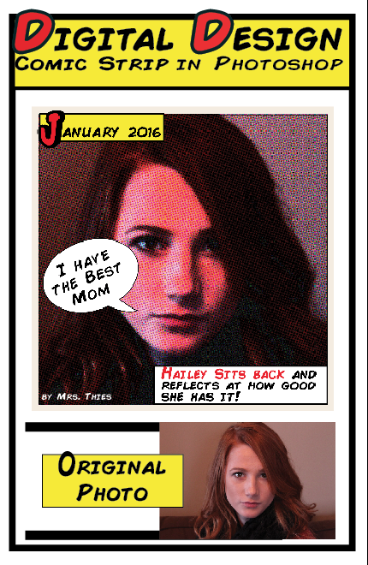
INDESIGN Poster part is complete  Correct Size: (1/2 sheet of paper) 5.5" Wide by 8.5" Height, .3" Margins | 5
Original Picture smaller than Comic one and placed on page | 5
Title: Digital Design Comic Strip in Photoshop Comic Font and something special done to it…see example (Character panel used) | 5
Design Elements and border:  Lines, shapes, color, contrast etc. | 10
Overall Look, Layout, content and cutout and put on construction paper | 10
TOTAL | 75

Name _______________________________________________
Rubric for Comic Strip Tutorial

Tutorial Website http://photoshoproadmap.com/give-your-photos-a-retro-comic-book-effect/ |  | Example below
Tutorial is well done and all instructions followed | 25
Font is Comic Font downloaded and Date put in square as shown. Text is appropriate and designed well (Example J in January) and put into a thought bubble or square as shown…. 10  Students name is put in lower left corner of comic as shown. 5 | 15
INDESIGN Poster part is complete  Correct Size: (1/2 sheet of paper) 5.5" Wide by 8.5" Height, .3" Margins | 5
Original Picture smaller than Comic on*e and placed on page | 5
Title: Digital Design Comic Strip in Photoshop Comic Font and something special done to it…see example (Character panel used) | 5
Design Elements and border:  Lines, shapes, color, contrast etc. | 10
Overall Look, Layout, content and cutout and put on construction paper | 10
TOTAL | 75

